 | Please: Sign your name under your Choice
Condiments: | 200-300 Attendees expected |  |  |  | Desserts
 | Dice&Sliced |  |  |  Slices | 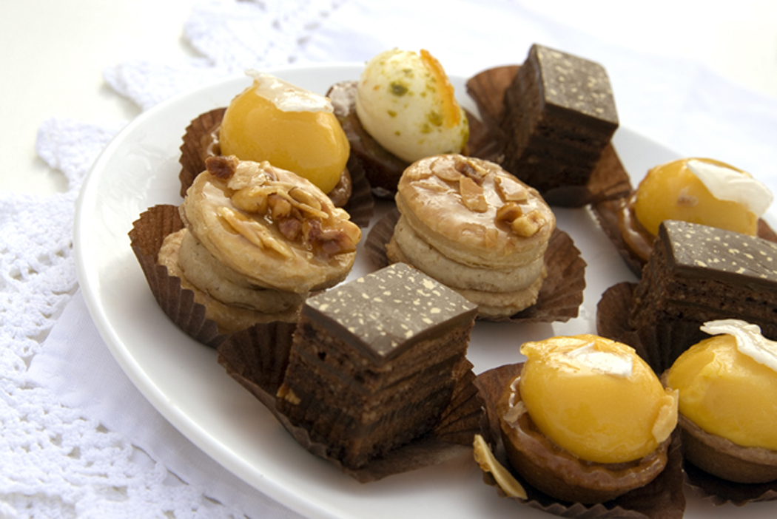  Varieties
B. Scarborough
Welcome Week Picnic 20010 BFSA Support

