**Prior Learning Assessment**

**Youngstown State University**

**Policies and Procedures**

**Draft**

Fall 2015

**Table of Contents**

**Introduction** . . . . . . . . . . . . . . . . . . . . . . . . . . . . . . . . . . . . . . . . . . . . . . . . . . . . . . . . . . . . . . . . 4

* General PLA Guidelines . . . . . . . . . . . . . . . . . . . . . . . . . . . . . . . . . . . . . . . . . . . . . . . 4

**Portfolio** . . . . . . . . . . . . . . . . . . . . . . . . . . . . . . . . . . . . . . . . . . . . . . . . . . . . . . . . . . . . . . . . . . . . .6

* Sites Where Learning Outside the Classroom Can Occur . . . . . . . . . . . . . . . . . . . . . .6
* Appropriate Application of Portflio Credit. . . . . . . . . . . . . . . . . . . . . . . . . . . . . . . . . .7
* New Courses Associated With PLA. . . . . . . . . . . . . . . . . . . . . . . . . . . . . . . . . . . . . . .7
* Steps for Students to Follow to Secure Academic Credit for Life Learning. . . . . . . . .8
* Roles of YSU Personnel . . . . . . . . . . . . . . . . . . . . . . . . . . . . . . . . . . . . . . . . . . . . . . . .8
* PLA Committee Members (Appeal Process). . . . . . . . . . . . . . . . . . . . . . . . . . . . . . . . 9
* Restrictions on Portfolio Credit. . . . . . . . . . . . . . . . . . . . . . . . . . . . . . . . . . . . . . . . . . 9
* Cost and Fees.. . . . . . . . . . . . . . . . . . . . . . . . . . . . . . . . . . . . . . . . . . . . . . . . . . . . . . . 10
* Closing Comment on Portfolio Assessment. . . . . . . . . . . . . . . . . . . . . . . . . . . . . . . .10

**Credit by Exam: Standardized and Department Challenge Exams**. . . . . . . . . . . . . . . . . . . 11

* Exams. . . . . . . . . . . . . . . . . . . . . . . . . . . . . . . . . . . . . . . . . . . . . . . . . . . . . . . . . . . . . .11
* Expansion, Standardization, and Centralization. . . . . . . . . . . . . . . . . . . . . . . . . . . . .11
* Additional Guidelines, Exam Specific. . . . . . . . . . . . . . . . . . . . . . . . . . . . . . . . . . . . 13
* Exam Processes and Fees. . . . . . . . . . . . . . . . . . . . . . . . . . . . . . . . . . . . . . . . . . . . . . .14
* Appeals. . . . . . . . . . . . . . . . . . . . . . . . . . . . . . . . . . . . . . . . . . . . . . . . . . . . . . . . . . . .14
* Closing Comment on Standardized Exams. . . . . . . . . . . . . . . . . . . . . . . . . . . . . . . . 14

**Militrary Credit**. . . . . . . . . . . . . . . . . . . . . . . . . . . . . . . . . . . . . . . . . . . . . . . . . . . . . . . . . . . . . .15

* How Credit is Evaluated and Applied to the Transcript. . . . . . . . . . . . . . . . . . . . . . .15
* General Education Credit Awarded by the Combination of Multiple Courses. . . . . 16
* Appeal Process. . . . . . . . . . . . . . . . . . . . . . . . . . . . . . . . . . . . . . . . . . . . . . . . . . . . . . 16
* Closing Comment on Military Credit. . . . . . . . . . . . . . . . . . . . . . . . . . . . . . . . . . . . 17

**Future Concerns/Tasks**. . . . . . . . . . . . . . . . . . . . . . . . . . . . . . . . . . . . . . . . . . . . . . . . . . . . . . . 18

* PLA Committee (Membership) . . . . . . . . . . . . . . . . . . . . . . . . . . . . . . . . . . . . . . . . 18
* Advisment (Training) . . . . . . . . . . . . . . . . . . . . . . . . . . . . . . . . . . . . . . . . . . . . . . . . 18
* Recruitment Strategies (Webpage and Crosswalks) . . . . . . . . . . . . . . . . . . . . . . . . . 18
* Outcomes and Assessment. . . . . . . . . . . . . . . . . . . . . . . . . . . . . . . . . . . . . . . . . . . . . 18
* PLA Policy Review Dates by Academic Senate. . . . . . . . . . . . . . . . . . . . . . . . . . . . 18

**PLA Committee Membership 2014-2017**. . . . . . . . . . . . . . . . . . . . . . . . . . . . . . . . . . . . . . . . . 19

**Appendices**

A PLA Coordinator Position Description. . . . . . . . . . . . . . . . . . . . . . . . . . . . . . . . . . . . . . 20

B How is YSU Currently Using Credit by Exam? . . . . . . . . . . . . . . . . . . . . . . . . . . . . . . . 24

How are Other Northeast Ohio Universities Using Standardized Exams?

C Sample Joint Services Transcript. . . . . . . . . . . . . . . . . . . . . . . . . . . . . . . . . . . . . . . . . . . 28

D Sample Webpage Design: Ivy Tech Community College, Indiana. . . . . . . . . . . . . . . . . 38

E Sample Crosswalks: Ivy Tech Community College, Indiana. . . . . . . . . . . . . . . . . . . . . 40

F Student Fees and Charges . . . . . . . . . . . . . . . . . . . . . . . . . . . . . . . . . . . . . . . . . . . . . . . . 42

**Youngstown State University**

**Prior Learning Assessment**

**Introduction**

Prior Learning Assessment (PLA) is a process that enables students to demonstrate what they have learned outside the classroom and translate that learning into college credit. PLA validates learning acquired through: corporate training programs, extensive volunteer activity, military service, workplace experience, civic engagement, individual readings and studies, training sponsored by professional organizations, and training sponsored by governmental agencies. PLA credit is awarded for college-level learning (knowledge, skills, and competencies) that students have obtained as a result of their prior learning experiences.

Student must demonstrate their mastery of the knowledge in order to earn college credit. Students can demonstrate prior learning by: performance on standardized test or department challenge exams; creation and evaluation of a portfolio; or demonstration of military service learning.

**General PLA Guidelines**

1. To apply for PLA credit, an individual must be eligible for admission to Youngstown State University and must be pursuing a certificate, associate, or bachelor’s degree at the time of application.
2. PLA credits satisfy prerequisite requirements in the same manner as their course equivalencies at Youngstown State University.
3. PLA credit can only be awarded when a student is enrolled in traditional, online, or distance education courses through Youngstown State University. The credit will be officially awarded at the end of the semester if the student successfully passes a minimum of six (6) semester hours of coursework.
4. Students may not apply for PLA credit for a course in which they are currently enrolled, for a course for which they have earned a failing grade, or for a course they have audited.
5. **PLA credit at Youngstown State University receives a grade of “CR” (Credit) or “NC” (No Credit). Awarded PLA credit is recorded by the University Registrar or his/her designee. No quality points are earned, and such credit does not enter into grade point average determination. When a student is awarded PLA credit, with a grade of CR, the credit may be applied to his or her major or minor areas of study. Other guidelines associated with the awarding of CR credit are not applicable to PLA credit hours.**
6. Youngstown State University accepts credit for PLA that has been awarded by other regionally-accredited institutions. These credits have the same limitations in their use in meeting graduation requirements as PLA credits earned at Youngstown State University.
7. A student who intends to transfer and use YSU PLA credit to meet degree requirements at another institution should consult the transfer institution to see if the PLA credit meets their requirements.
8. A student who has not earned college-level credit in a subject area may take a standardized exam (CLEP, DSST, etc.) for courses offered by Youngstown State University.
9. To award PLA credit, the appropriate faculty member will develop a matrix or rubric that clearly identifies the published course learning outcomes and/or the process for assessing mastery level. The rubric or matrix will be endorsed by the department chairperson or chairperson designee.
10. All work assessed for PLA credit must meet a minimum of “C” level proficiency; the “C” level must be determined by faculty members in order to maintain academic integrity and rigor. An exception is permitted for a course that is not required in the major. The exception must be granted by the department chairperson or chairperson designee. In some situations, such as an elective general education course, a minimum of “D” level proficiency may be acceptable (as required by the Ohio Board of Regents – “**PASSING GRADE -** Passing grades include the grades of A, B, C, and D. The grade of D- is also included as passing at some, but not all, Ohio institutions” -https://www.ohiohighered.org/node/633 ).
11. All materials associated with PLA credit become the property of Youngstown State University.
12. PLA credit does not count toward Youngstown State University’s residency requirements:

Final hours – The last 20 semester hours leading to an associate degree and the last 30 semester hours leading to a baccalaureate degree must be completed at YSU. (In the pre-forestry, pre-law, and pre-medical curricula, which allow the student to earn final hours in absentia, the last 30 semester hours prior to the period of absence must be spent at YSU.)

Concentration area/Major hours – A minimum of 16 semester hours in the concentration area for the associate degree and a minimum of 16 semester hours of credits within the major in a baccalaureate degree must be earned in residence.

Upper-division hours – A minimum of 21 semester hours of upper-division credit for the baccalaureate degree must be earned in residence.

Additional college requirements – Additional residency requirements may be specified by individual colleges.

**Portfolio**

Many adult (non-traditional) students may underestimate the value of learning that has occurred during their life experiences. Each day that a person works, engages the community, serves others, reads, and performs other various activities provides opportunities for him or her to learn valuable and quality knowledge. Some of this knowledge may approximate college level learning, and such learning can be evaluated and may be awarded college credit. One option for evaluation of such learning is the development of a portfolio for evaluation by YSU faculty.

A portfolio isa collection of information and documentation submitted by a student to demonstrate learning that has occurred outside the traditional college classroom. A portfolio documents skills and concepts that an individual has learned as a result of his or her life experiences and ties those skills and concepts to learning outcomes associated with specific courses or programs. This learning could have resulted from jobs, hobbies, volunteer work, training seminars, or other experiences resulting in intellectual growth and understanding. It should be highlighted that college credit for these experiences can be awarded only upon demonstration of college-level learning applied to specific learning outcomes. This credit cannot be awarded simply for life experience.

**Sites Where Learning Outside the Classroom Can Occur:**

|  |  |
| --- | --- |
| • Jobs  •Workshops  • Seminars  • Religious Organizations  • Hobbies  • Travel  • Civic Involvement | • Work-Related Training  • Professional Licenses  • Professional Certifications  • Professional Memberships  • Professional Accomplishments  • Community Service  • Volunteer Services |

The documentation a student presents to demonstrate the mastery of learning varies by course and may include: a self-assessment; awards; honors; examples of documents developed; examples of materials made (like a machine part); an essay explaining knowledge and experience; documents developed at work; documents developed during a civil engagement; certificates showing completion of workshops; or certificates showing completion of a seminar offered by professional organizations, business, industry, or government agencies. Preparation and content of the portfolio are the responsibility of the student and must be of sufficient breadth and depth to validate the student’s stated learning and provide the evaluators with qualitative evidence for evaluation. A PLA course, PLA 1500: Portfolio Development, was developed to instruct students in building a satisfactory portfolio. A student may not receive PLA credit for a portfolio without first completing PLA 1500.

**Appropriate Application of PLA Credit**

PLA credit may be awarded in the following ways:

* The primary goal is to award credit equated to courses with specific learning outcomes.
* Learning may be equated to an internship/clinical experience.
* If it is determined that a student’s learning is too broad or overlaps learning outcomes from various courses, then PLA credit may be awarded in one of the following courses: PLA 2600 (lower division credit) or PLA 3700 (upper division credit). The level of learning and the amount of credit awarded will be determined by YSU faculty members.

If it is determined that a student will be awarded PLA credit in the courses PLA 2600 or 3700, then the YSU faculty members, in consultation with the department chairperson, will apply the credit to the student’s degree in one of the following ways:

* Substitution for required courses within the major
* General elective hours within the major
* General elective hours outside the major

**New Courses Associated with PLA**

1. PLA 1500: Portfolio Development

This course examines the importance of learning outcomes and the ways in which faculty evaluate the achievement of those outcomes. The course walks students through the process of evaluating their own experience for the achievement of college-level learning and the demonstration of that learning through the preparation of an academic portfolio. Fee: $300. CR/NC (1 s.h.).

1. PLA 2600: Prior Learning Assessment (based on the course LASS 3780: Lifetime Learning Experience)

This course offers credit for learning that has occurred outside the traditional academic classroom awarded for college-level learning (knowledge, skills, and competencies) that students have obtained as a result of their prior learning experiences. Mastery is deemed undergraduate lower-level learning. Prereq.: PLA 1500, at least 6 s.h. of coursework at Youngstown State University, and consent of the appropriate chairperson. Credit may be applied to the transcript multiple times. CR/NC (1 – 15 s.h.).

1. PLA 3700: Prior Learning Assessment (formerly LASS 3780)

This course offers credit for learning that has occurred outside the traditional academic classroom awarded for college-level learning (knowledge, skills, and competencies) that students have obtained as a result of their prior learning experiences. Mastery is deemed undergraduate upper-level learning. Prereq.: PLA 1500, at least 6 s.h. of coursework at Youngstown State University, and consent of the appropriate chairperson. Credit may be applied to the transcript multiple times. CR/NC (1 – 15 s.h.).

**Steps for Students to Follow to Secure Academic Credit for Life Learning:**

1. Contact the PLA Coordinator (if no coordinator has been named, then contact a member of the PLA Committee).
2. Complete the PLA Credit Application.
3. The PLA Coordinator will direct the student either to complete the online PLA 1500: Portfolio Development course or take a standardized or department challenge exam.
4. If the PLA Coordinator determines that the student meets the minimal requirements to apply for portfolio-based credit, then the student will be advised to complete the online PLA 1500: Portfolio Development course (1 s.h. of credit; grade option is CR/NC; fee of $300). Complete the application form and follow instructions on the form and those discussed in PLA 1500.
5. If the student’s prior learning does not match a specific course or discipline-related internship/clinical experience, then the PLA Coordinator will meet with an appropriate department chair to discuss and determine if appropriate learning outcomes exist in which to assess the life learning. The student will be informed once these learning outcomes are established so that an appropriate portfolio can be developed.

**Roles of YSU Personnel including Appeal Process**

**Faculty Members**

* Develop learning outcomes for specific courses (as needed).
* Review portfolios (faculty members receive a nominal stipend of approximately $125 for each portfolio reviewed – students are paying a fee of $150.00 per review; fringe benefits are deducted prior to faculty being paid for the review). Two faculty members will review each portfolio. If there is a split decision about the awarding of PLA credit and how it is to be applied to the degree, then the department chairperson will review the portfolio and make a final decision. If the department chairperson believes he or she does not have the discipline-related knowledge to make the final decision, then she or he may assign a third faculty member to evaluate the portfolio.
* Assist chairpersons in deciding how to apply PLA credit.

**Chairpersons**

* The chairperson will determine who, based upon the expertise of the faculty members, should be assigned to evaluate the portfolio. If the faculty member declines the assignment, another faculty member will then be selected. If necessary, the department chairperson may assign the task to an adjunct faculty member.
* The chairperson or chairperson designee will serve as a tie breaker (if needed).
* If it is determined that PLA 2600 or 3700 credit is to be awarded, then the department chairperson, in consultation with the faculty members who evaluated the portfolio, will determine the amount of credit to be awarded, the mastery level (lower or upper division), and the application of the hours to the degree (substitute for required courses, substitute for elective courses in the discipline, or substitute for general elective hours outside the major).
* If it is determined that the credit to be awarded is PLA 2600, and the department chairperson, in consultation with the faculty members who evaluated the portfolio, recommend general education credit, the portfolio will be reviewed by the General Education Coordinator and the appropriate GE Domain representative. Courses receiving a unanimous vote of approval will receive GE credit. Portfolio credit for General Education cannot be award to experience already evaluated by the other methods. PLA 3700 is not eligible for General Education Credit.
* The chairperson will: 1) notify the Records Office of credit to be placed on the student’s transcript; 2) assure that the student completes the proper paperwork; and 3) inform the student about how to pay required fees.

**PLA Committee Members (Appeal Process)**

* The PLA Committee serves as the appeal body for students in cases in which procedures or evaluation may have been handled improperly. A student’s appeal must be filed within 30 days of the decision to either award or to not award credit. Failure to recommend credit does not constitute improper procedure.

**Restrictions on Portfolio Credit**

* A student will not be awarded credit for being a client or resident of an agency or organization.
* A student may not request portfolio evaluation for an academic course that he or she enrolled in and failed to pass.
* Student may not request portfolio evaluations for the same experiences multiple times from different departments.

**Cost and Fees**

Students must pay for the one (1) semester hour course, PLA 1500: Portfolio Development, (taught by the PLA Coordinator or a designee) at the standard enrollment cost. This course focuses on the role of learning outcomes and methods of demonstrating that mastery of the learning has occurred. The student must pay a $300 fee for the evaluation of the portfolio. For each semester hour of credit awarded, the student must pay a transcription fee of $30.00 per semester hour.

**Closing Comment on Portfolio Assessment**

The amount of portfolio credit awarded depends upon the depth, length, and quality of the learning that has occurred. Credit will only be awarded to students for demonstration that course learning outcomes have been achieved. Further, students should be aware that some learning experiences have no YSU course equivalent. In such cases, although the learning by the student may be valuable, there is simply no course for which a student can be awarded credit.

**Credit by Exam**

**Standardized and Department Challenge Exams**

Any student who believes he or she is qualified to earn college credit based upon experience, previous training, or noncredit coursework may request credit by examination. The examination will be thorough and in keeping with the established goals and objectives of the course(s) and the overall academic program. Theoretical knowledge will be tested by faculty recommendation through common acceptable measures (i.e., paper and pencil, computerized, etc.) with the possibility of a skills component. Both written and skills testing may be required to insure “course rigor” is maintained and achieved.

**Exams**

Youngstown State University offers standardized exam and department challenge exam testing.

**Standardized Exams** refer to college-level examinations delivered by a third-party vendor that allow students to receive college credits in certain courses. Two common types of standardized exams accepted at YSU are:

CLEP – College Level Examination Program – CLEP exams assess proficiency in general education through 33 tests. Most CLEP exams cover lower level and introductory knowledge in these primary areas: mathematics, writing, communications, and science.

DSST (formally called DANTES Subject Standardized Tests) – DSST examinations test knowledge in both lower and upper-level college material through 38 tests in six subject areas.

In addition to Standardized Exams, YSU also offers **Department Challenge Exams**. Developed by YSU faculty members, these exams measure a student’s mastery of the learning outcomes associated with a particular course.

Department Challenge Exams - Currently-enrolled students may demonstrate their ability and knowledge in a particular subject area by taking a special examination (through the appropriate academic department). The exams are based upon established learning outcomes. Students are provided with a recommended reading list and/or a study guide to prepare for the examination.

**Expansion, Standardization, and Centralization**

Youngstown State University will expand credit by exam opportunities for all students, standardize the process by which students utilize credit by exam opportunities across campus, and centralize the administration of such credit by exam opportunities.

Expansion (Standardized Exams):

As of Spring 2015, Youngstown State University only accepts 14 of the 33 CLEP exams available to students. YSU accepts fewer CLEP exams than any other northeast Ohio university by almost one-half (see Appendix B). The CLEP program at Youngstown State University will be expanded across campus to encompass all CLEP exams by Fall 2015. If the faculty members in a department deem the CLEP exam in their discipline does not meet academic rigor, then the faculty members, or a subgroup of the faculty members, may develop a challenge exam to replace the CLEP exam. The decision to create a challenge exam instead of accepting the CLEP exam must be provided in writing to the following individuals by September 30, 2015: department chairperson, dean of the college, manager of the YSU Comprehensive Testing Center, and the members of the PLA Committee. The department challenge exam should be sent to the Comprehensive Testing Center no later than December 1, 2015. Testing will be administered at the testing center and forwarded to the department for grading.

In some situations, faculty members may not be convinced that an exam permits a student to demonstrate his or her mastery of the knowledge and/or skills of a particular course for which CLEP provides an exam. If this occurs, then the department may require a portfolio prior to considering awarding PLA credit. The decision to require a portfolio instead of a CLEP or department challenge exam must be provided in writing to the following individuals by September 30, 2015: department chairperson, dean of the college, manager of the YSU Comprehensive Testing Center, and the members of the PLA Committee.

***The procedure listed above will also be followed for the DSST exams.***

Expansion (Department Challenge Exams):

The following individuals should be notified when an academic department develops a challenge exam: department chairperson, dean of the college, manager of the YSU Comprehensive Testing Center, and the members of the PLA Committee. This information will then be placed on the YSU website. If any department is currently offering challenge exams, then that information should be submitted by September 30, 2015, so it can be included on the website. The department challenge exam should be sent to the Comprehensive Testing Center no later than December 1, 2015. Testing will be administered at the testing center and forwarded to the department for grading.

Standardize:

Youngstown State University will develop a standardized and easily accessible procedure by which students can take advantage of credit by exam opportunities and must prominently promote the array of these opportunities to the student body. To assist in accomplishing this goal, YSU will maintain an updated webpage detailing exam opportunities to students. The PLA webpage must be reviewed and updated bi-monthly by the PLA Coordinator or a designee. The PLA and Comprehensive Testing Center webpages will be linked to each other.

The application form to take an exam (standard or challenge exam) will be available to students on the PLA website along with a list of available CLEP, DSST, and department credit by exams. Students will be directed to complete the application form and submit it to the PLA Coordinator or designee (see below) who will then forward the document to the appropriate department for approval. The PLA Coordinator would then arrange for the testing to take place at the Comprehensive Testing Center.

Centralize:

In order to help standardize the credit by exam process for students, PLA information will be centralized in a designated PLA office which is administered by a PLA Coordinator (see Appendix A for list of responsibilities and tasks). The PLA Coordinator or designee will be responsible for responding to student questions, providing a point of entry from which students begin the credit by exam process, developing and maintaining a PLA website, and collaborating/coordinating with departments and the Comprehensive Testing Center in updating and establishing policies and reviewing materials.

**Additional Guidelines, Exam Specific**

1. Students may NOT take a CLEP test, department challenge exam, or other credit by exam opportunity for any course in which they are currently enrolled or have previously been enrolled and earned an evaluative grade (A-F, AU, INC, NF, CR, NC).
2. Students who have already received credit for coursework for a subject in which the courses are sequential may not receive academic credit by means of CLEP, department challenge exam, or other credit by exam opportunity for an earlier prerequisite course.
3. Students pursuing a baccalaureate degree may earn up to a maximum total of 30 semester hours via credit by exam (CLEP, AP, departmental exams, etc.). Students pursuing an associate degree may earn a maximum total of 15 semester hours via credit by exam. Students who wish to take more than the maximum permitted may petition their college dean for a waiver of this limitation. Students who have earned more than the maximum permitted credits by exam (e.g., AP and/or CLEP) before attending YSU will be granted academic credit, provided such credit meets YSU standards.
4. Students should consult with their academic advisor for further information regarding the applicability of CLEP, department challenge exam, or other credit by exam opportunity toward specific degree requirements.
5. According to College Board policy, students wishing to retake a CLEP exam must wait three months before retesting. This policy is subject to change based upon College Board policy.

**Exam Processes and Fees**

Students requesting Standardized Exams must pay the non-refundable third party vender fee for CLEP, DSST, etc. plus a non-refundable $25 university processing fee. **All university processing fees are waived for active military and university veterans.**

Students who are interested in the CLEP program register for a CLEP exam via the Comprehensive Testing Center (CTC) webpage at [www.ysu.edu/testing](http://www.ysu.edu/testing). Information on the two-step process for test registration can be found by clicking on “credit by exam” and following the outlined instructions. When registering for a test, students incur two fees, an $80.00 exam fee assessed by College Board and a $25 YSU administrative charge by the Comprehensive Testing Center.

Once a YSU student has successfully completed a CLEP exam and met the qualifying score, an official transcript is sent from College Board to YSU’s Records Office and the student is awarded credit for the course associated with the exam on his/her academic transcript.

Students requesting Department Challenge Exams must do so with the assistance of the PLA Coordinator. Students have to identify the course in which they believe they have mastered the subject matter. The department chairperson will be contacted to see if a department challenge exam exists or can be written. If a challenge exam is not available, then students may complete portfolios for evaluation. The goal is to offer department challenge exams when possible. Each department challenge exam should have a reading list and/or study guide available for the students.

If it is determined that a student may take a department challenge exam, then he or she must complete an application form for Credit by Examination, which must be signed by the PLA Coordinator, departmental chair, college dean, and a student accounts representative. Exams are administered in the Comprehensive Testing Center. When an exam is completed, the chairperson must sign the application form and send the document to the Records Office.

**Appeals**

Students may not appeal the grade of the exam. They may appeal the process to the PLA Committee. This appeal must be submitted within 30 days of the grade being posted.

**Closing Comment on Standardized Exams**

Currently, the YSU Comprehensive Testing Center offers a wide array of professional exam certifications via partnerships with professional testing companies such as Pearson Vue, Castle, Comira, Prov, and Kryterion. These certifications, among others, could provide additional PLA opportunities for students attending YSU. Departments interested in this option should contact the Comprehensive Testing Center to discuss these opportunities.

**Military Credit**

Youngstown State University recognizes the depth of learning that occurs when an individual serves in the armed forces. The Air Force provides colleges and universities transcripts for their military personnel. The other Armed Forces provide a Joint Service Transcript (JST) which also provides colleges and universities transcripts for military personnel (please see Appendix C for an example of a JST). The credit on a JST has been evaluated and assigned by the **American Council on Education (ACE)**. The credit found on the Air Force and JST is credit awarded for classroom and skills/laboratory learning. This credit is placed on Youngstown State University’s transcripts for students as transfer credit.

**How Credit is Evaluated and Applied to the Transcript**

* Students must provide a copy of their military transcript to the Office of Veterans Affairs who will then submit it to the Office of Degree Audit for inclusion on the YSU transcript. Any credit on the JST, as evaluated by ACE, will be placed on the student’s transcript as transfer credit according to ACE guidelines.
* Basic Training equates to HPES 15xx SPA-WB (Social and Personal Awareness – Well Being) for all students according to the ACE guidelines.
* All courses determined by ACE to be lower or upper division credit will be placed on the transcript. The Office of Degree Audit or the PLA Coordinator may ask an Academic Department to determine if the course is equivalent to a course offered in their discipline(s). This would be a similar process used to evaluate other transfer credit. If it is determined that the course is equivalent to a YSU course, then the application of credit will apply to all military personnel that have completed that course. If it is determined that the credit to be awarded is for general education credit, the course will be reviewed by the General Education Coordinator and the appropriate GE Domain representative. Courses receiving a unanimous vote of approval will receive GE credit.
* If ACE guidelines indicated that a course is a technical course, then approval to place the credit hours on the student’s YSU transcript must be obtain from an Academic Department. The PLA Coordinator can assist the student in determining which Academic Department would be the appropriate Academic Department from which to seek that permission; it should be noted that the Academic Department may require testing or a portfolio review prior to awarding any credit for technical learning.
* Not all courses listed on the JST are awarded the same number of semester hours as a course at Youngstown State University. Please see Appendix C. In these situations, an Academic Department has the ability to combine two or more courses that they believe together are equivalent to a course offered in their Department. That decision rest entirely with an Academic Department

**General Education Credit When Awarded by the Combination of Multiple Courses**

* The minimum credit hours needed for a course to be designated a General Education course is 3 semester hours. The Faculty Members of the Veterans Affairs Council will review students’ JSTs to determine if the **combination of courses** on the JST will meet the learning outcomes associated with a General Education domain.
* If the Faculty Members of the Veterans Affairs Council believe that the combination of courses on the JST meet the learning outcomes of a General Education domain, then they will recommend that ELCT 15xx (with designated domain) be placed on the student’s official YSU transcript.
* The request will then be forwarded to the Coordinator of the General Education Committee.
* The determination to award the recommended General Education credit will be made by the General Education Coordinator in consultation with an appropriate GE Domain Representative.
* Courses receiving an unanimous vote of approval by the General Education Committee will receive general education credit.

Active military or university veterans are also encouraged to take exams such as CLEP and DSST were applicable. They are also encouraged to develop a portfolio to address potential credit to evaluate learning that occurred outside of that recommended by ACE. This is highly encouraged for active military or university veterans that have served overseas to evaluate if general education can be awarded for Social and Personal Awareness – International Perspective. Students need to meet with the Office of Veterans Affairs or the PLA Coordinator for guidance on how to obtain credit for learning that has occurred outside the classroom environment. Students need to be aware that ACE evaluated courses may not meet prerequisite requirements in some disciplines. Students should meet with an academic advisor to assure that they have the required prerequisites for upper division courses.

**Appeal Process:**

* Students may not appeal the determination of course equivalents by an Academic Department.
* Students may not appeal the determination of general education equivalents by the General Education Committee.
* Students may appeal the process to the PLA Committee.

**Closing Comment on Military Credit**

Youngstown State University is proud of its designation of being a “military friendly” institution for the past six years. YSU is committed to meeting all the requirements of House Bill 488 which was recently signed into law by Governor Kasich on June 16, 2014. The bill provides, among other things, easier access to education for veterans and requires state education institutions to offer a means by which military members are awarded appropriate and adequate college credit for their military training, experience, and course work. The application of credit to our active military and university veterans is in line with three of President Tressel’s stated goals during his installment speech. He said he wanted to increase enrollment, decrease the amount of time students take to earn their degree, and reduce the amount of loans being used to obtain a degree.

**Future Concerns/Tasks**

The PLA Policies and Procedures Manual at Youngstown State University is a living document. It will be reviewed and corrections made if deemed necessary on a bi-monthly schedule. The PLA Committee is responsible for meeting and completing the following tasks. The primary focus of the PLA Committee for Spring 2015 is the approval of the *PLA Policies and Procedures* manual. In the summer, the PLA Committee will have many tasks to complete. The primary focus in Summer 2015 will be determining who is responsible for the implementation, maintenance, and obligations of Youngstown State University’s PLA Policies. If a PLA Coordinator cannot be employed or assigned, then the PLA Committee will have to develop a plan of action to sure that the responsibilities of that coordinator are cared out.

**PLA Committee (Membership):** The original membership of the PLA Committee was selected by the co-chairs. They selected individuals who had an understanding of testing, protfolios, and military service. Two individuals were selected by college deans. The PLA Committee, working with the Academic Senate, must establish how members will be selected and/or assigned to serve on the committee. This process must be completed by Fall 2016.

**Advisement (Training):** The needs of adult learners are different than those of traditional students in many situations. Advisors, faculty members, staff, and administrators need to be trained on how to advise and assist adult learners. All these individuals will also need training on how to properly promote and administer PLA policies at Youngstown State University. A basic training program should be offered by late Summer 2015 or early Fall 2015. If the University does not have a PLA Coordinator in place by mid-summer 2015, then the PLA Committee will have to address the issue of training.

**Recruitment Strategies (Webpage and Crosswalks):** The success of PLA depends upon several key items being in place. It is imperative that YSU develop a webpage that focuses on adult learners and PLA (see Appendix D for an example). A successful PLA plan has “Crosswalks for Certificates” (see Appendix E) in place. These crosswalks need to be discussed, evaluated, and developed. To help assure a successful PLA initiative, partnerships with area business must be developed, and degree completion programs need to be instituted. If the University does not have a PLA Coordinator in place by mid-summer 2015, then the PLA Committee will have to address these strategies for growth.

**Outcomes and Assessment:** According to the Ohio Board of Regents, each state university and college will have to provide data concerning their PLA programs. At the time of this publication, the exact expectations of the needed data or procedures for collecting and reporting have not been established.

**PLA Policy Review Dates by Academic Senate:** The PLA Policies and Procedures Manual must be reviewed during spring semester every even year (next evaluation period: Spring 2016).

**PLA Committee Members 2014 – 2017**

Kevin Ball, Associate Provost (Co-Chair)

Tammy A. King, BCHHS Associate Dean (Co-Chair)

Rick Williams, Coordinator of the Office of Veterans Affairs

Megan Collins, Financial Aid Counselor

Amy Gordon, Comprehensive Testing Center Manager

Sharon Mika, Assistant Director of Transfer

Kim Verdone, Director of Academic Credit Transfer, Degree Audit, and Transfer Articulation

Bill Buckler, Coordinator of Academic Advising

Gary Swegan, Associate Vice President for Enrollment Planning and Management

Mike Crist, Interim Dean of CCAC (currently on leave from the PLA Committee)

Alan Tomhave, Assistant Professor, Philosophy & Religious Studies

Sue Miller, Academic Advisor and President of YCADA

John Martin, Assistant Professor, School of Engineering Technology

Susan DeBlois, Associate Professor, Educational Foundations, Research Technology, and Leadership

Mike Costarell, Associate Professor, School of Engineering and Technology

**Appendix A**

**PLA Coordinator Position Description**

**and Responsibilities**

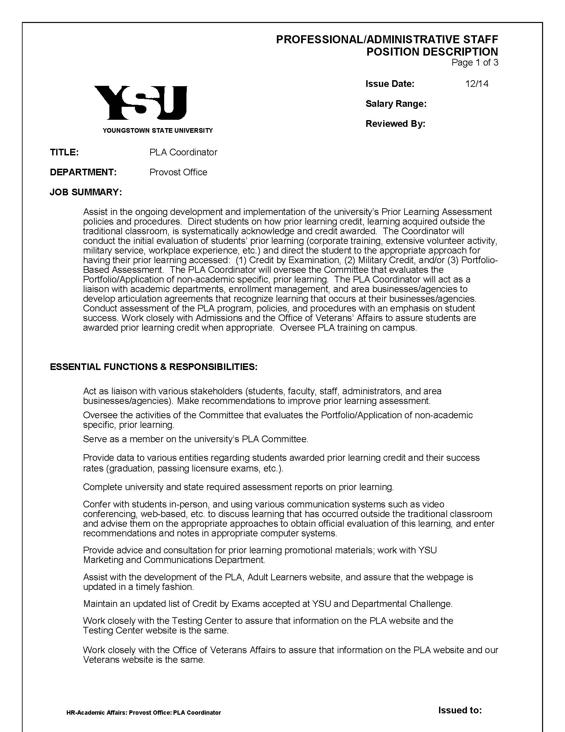

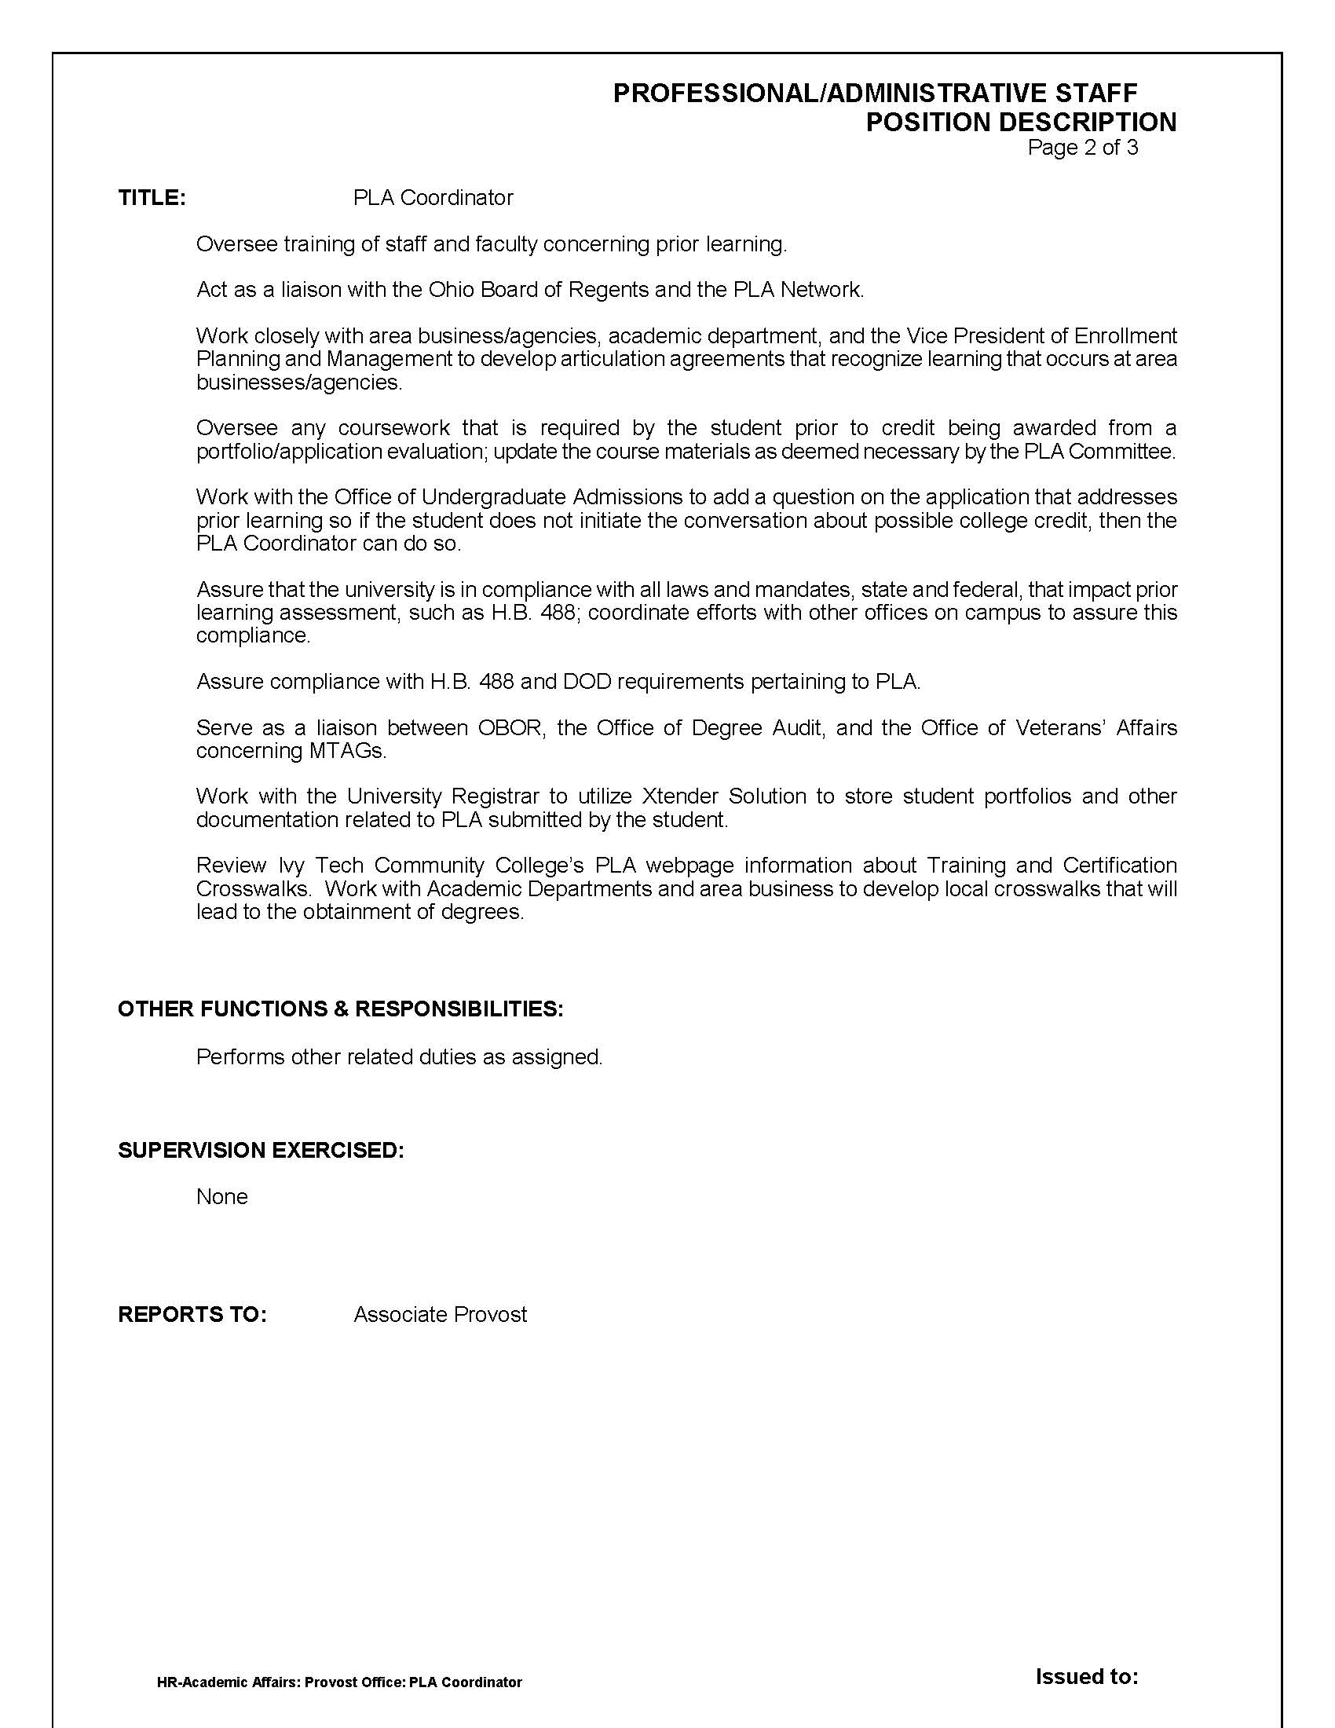

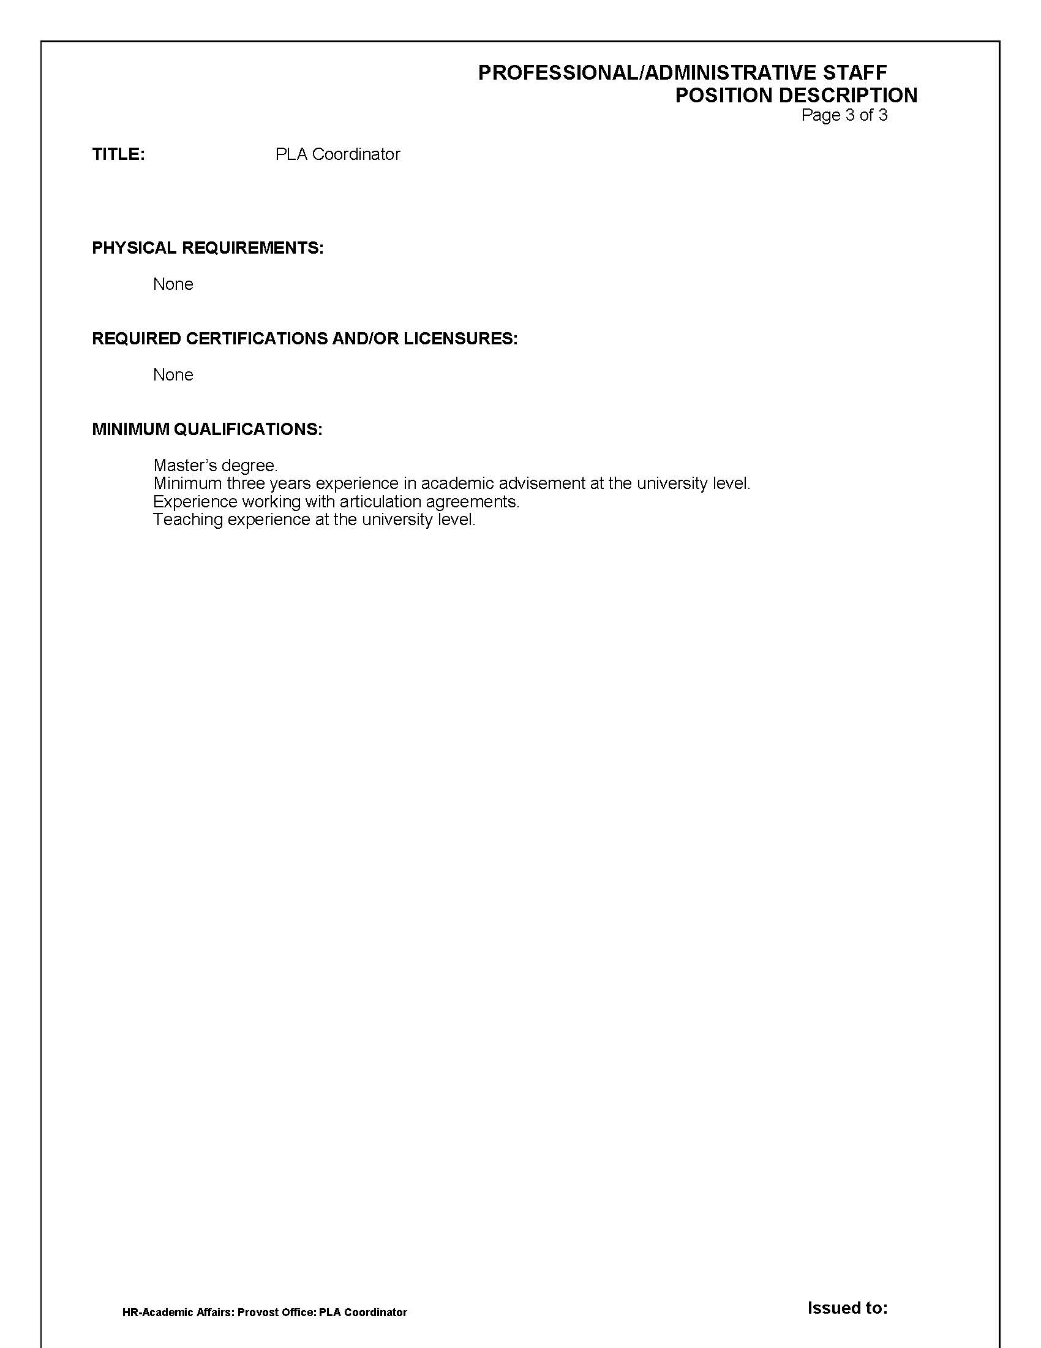

**Appendix B**

**How is YSU Currently Using Credit by Exam?**

**How are Other Northeast Ohio Universities Using Standardized Exams?**

**How is YSU Currently Using Credit by Exam?**

**How are Other Northeast Ohio Universities Using Standardized Exams?**

As of Spring 2015, YSU offers students three ways by which they may earn college course credit by exam (CBE): 1) high school students in AP (College Board’s Advanced Placement) or IB (International Baccalaureate Organization) courses may take AP or IB exams that can earn college credit; 2) YSU students may take CLEP (College-Level Examination Program) exams developed by the College Board to earn credit for specific courses; and 3) YSU students may earn credit for designated courses by satisfactorily passing exams established by academic departments. At this time, YSU does not accept credit resulting from DSST exams (recommended by the American Council of Education - ACE).

**CLEP**

At present, students at YSU have the ability to take only 10 of 33 available CLEP exams. The specific exams and qualifying scores are listed below.

|  |  |  |  |
| --- | --- | --- | --- |
| **CLEP Exam** | **Required Score** | **Credit Granted** | **Equivalent Course** |
| General Biology 1 | 50 | 4 | BIOL 2601, 2601L |
| General Chemistry | 50 | 8 | CHEM 1515, 1515L & 1516, 1516L |
| Introductory Business Law | 51 | 3 | MGT 2604 |
| Natural Science | 50 | 6 | PHYS 1500, BIOL 1505 |
| Principles of Macroeconomics | 50 | 3 | ECON 2630 |
| Principles of Microeconomics | 50 | 3 | ECON 2610 |
| Psychology | 50 | 3 | Psych 1560 |
| French Language | 36  50  62 | 4  4  3 | FRNCH 1500  FRNCH 2600 only  FRNCH 2605 only |
| German Language | 36  40  42 | 4  4  3 | GERMN 1550  GERMN 2600 only  GERMN 2605 only |
| Spanish Language | 41  50  66 | 4  4  3 | SPAN 1550  SPAN 2600 only  SPAN 2605 only |

Students who are interested in the CLEP program register for a CLEP exam via the Comprehensive Testing Center (CTC) webpage at [www.ysu.edu/testing](http://www.ysu.edu/testing). Information on the two-step process for test registration can be found by clicking on “credit by exam” and following the outlined instructions. When registering for a test, students incur two fees, an $80 exam fee assessed by College Board, and a $25* YSU administrative charge by the Comprehensive Testing Center. YSU’s CLEP administration fee is comparable to that of YSU’s competitor universities:

* U Akron $25
* Kent $35
* Cleveland State $30
* BGSU $20
* OSU $40

\**All YSU CLEP test administration fees are waived for active military and university veterans*.

Once a YSU student has successfully completed a CLEP exam and met the qualifying score, an official transcript is sent from College Board to YSU’s Records Office and the student is awarded credit for the course associated with the exam on his/her academic transcript.

**How are competitor universities using Credit by exam:**

PLA Credit by exam subcommittee members reviewed the credit by exam policies at several competing institutions.

Summary of findings:

**University of Akron**

Accepts 23 CLEP exams. Score of 50 considered passing (Foreign Language is an exception)

Accepts IB/AP/DSST

Has nearly 100 courses approved for Bypass credit. Students can pass the class with a C or better and can apply to have the prerequisite coursework credit awarded as well.

Credit by Exam allowed with dean’s approval.

Guidelines for CBE

* Grade on exam is grade for course
* Must complete before start of last semester
* May not use to change a course grade.

No clear CBE outlined on web information

**Kent State**

Has 481 Departmental Credit by exam opportunities

Accepts 24 CLEP Exams

Accepts IB/AP/DSST exams

Guidelines

* Students may only attempt a CBE test once.
* Does not permit students to test out of earlier prerequisite coursework if subsequent coursework has been completed.
* Hour restrictions:
  + Baccalaureate – maximum of 30hrs CBE/CLEP/AP combined
  + Associate – maximum of 15 hrs CBE/CLEP/AP combined
    - Permit petition to Dean for waiver of hour restriction
* Must complete all CBE/CLEP opportunities before the final semester before graduation
* Must complete exams within 60 days of date of payment/application for exam
* Not applied to residency requirement.

**Cleveland State University**

Accepts all 33 CLEP exams. Score of 50 passing (FL excluded)

Departmental Credit by Exam

Guidelines

* 30 Credit hour limit
* Not applied to residence requirement.
* No credit is awarded for courses in which the student has already earned or been granted credit.
* No approval when the exam has been repeated.

**Eastern Gateway Community College**

No clear CBE information on website.

Information on “Credit for Life”

**Lorain County Community College**

Accepts 23 CLEP exam

Divisional Proficiency Exams/Department Exams

Professional Examinations – student’s eligibility to receive credit for an LCC course or group of courses related to the skills or competencies tested on the exam.

*Well-developed website for both students and faculty. PLA Forms can be found online.

**Stark State Community College**

Accepts up to 12 hrs CLEP credit

**CAEL Report**

The Council for Adult and Experiential Learning released a study in March of 2010. The data, collected from 62,475 students at 48 postsecondary institutions showed that students who had access to PLA opportunities had better outcomes than students who did not, “particularly in terms of graduation rates and persistence, than other adult students. Many PLA students also shortened the time required to earn a degree, depending on the number of PLA credits earned.” Link to CAEL Report: http://www.cael.org/pdf/pla_fueling-the-race.pdf.

**Appendix C**

**Sample Joint Services Transcript**

**(http://jointservicetranscript.com/files/Army_JST_Sample.pdf)**

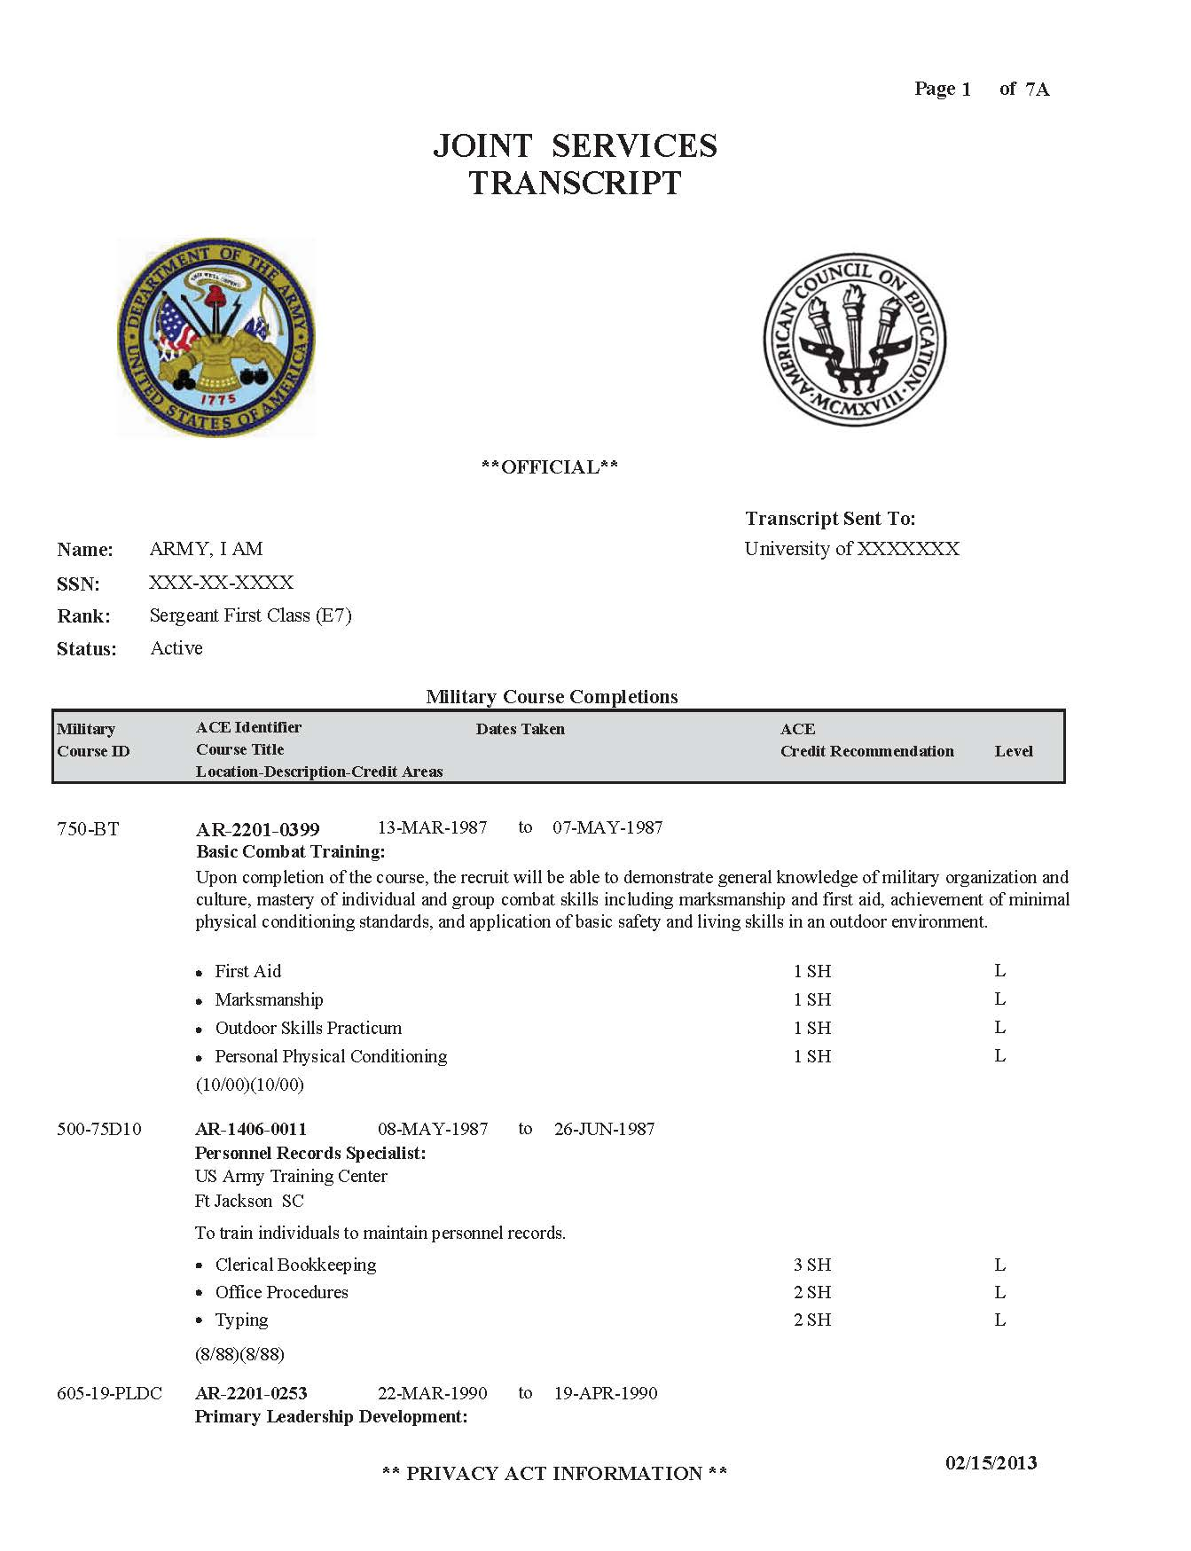

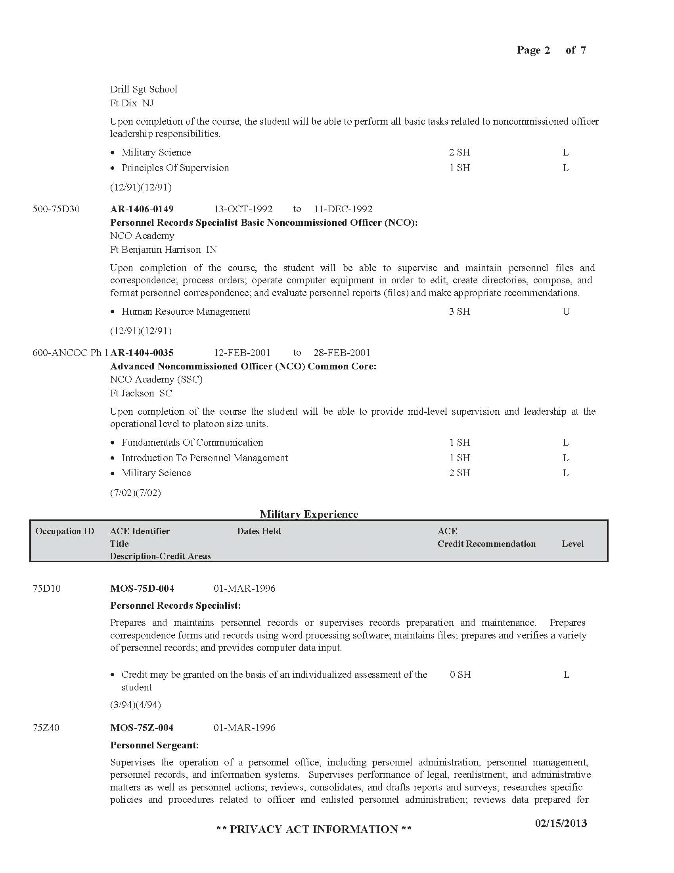

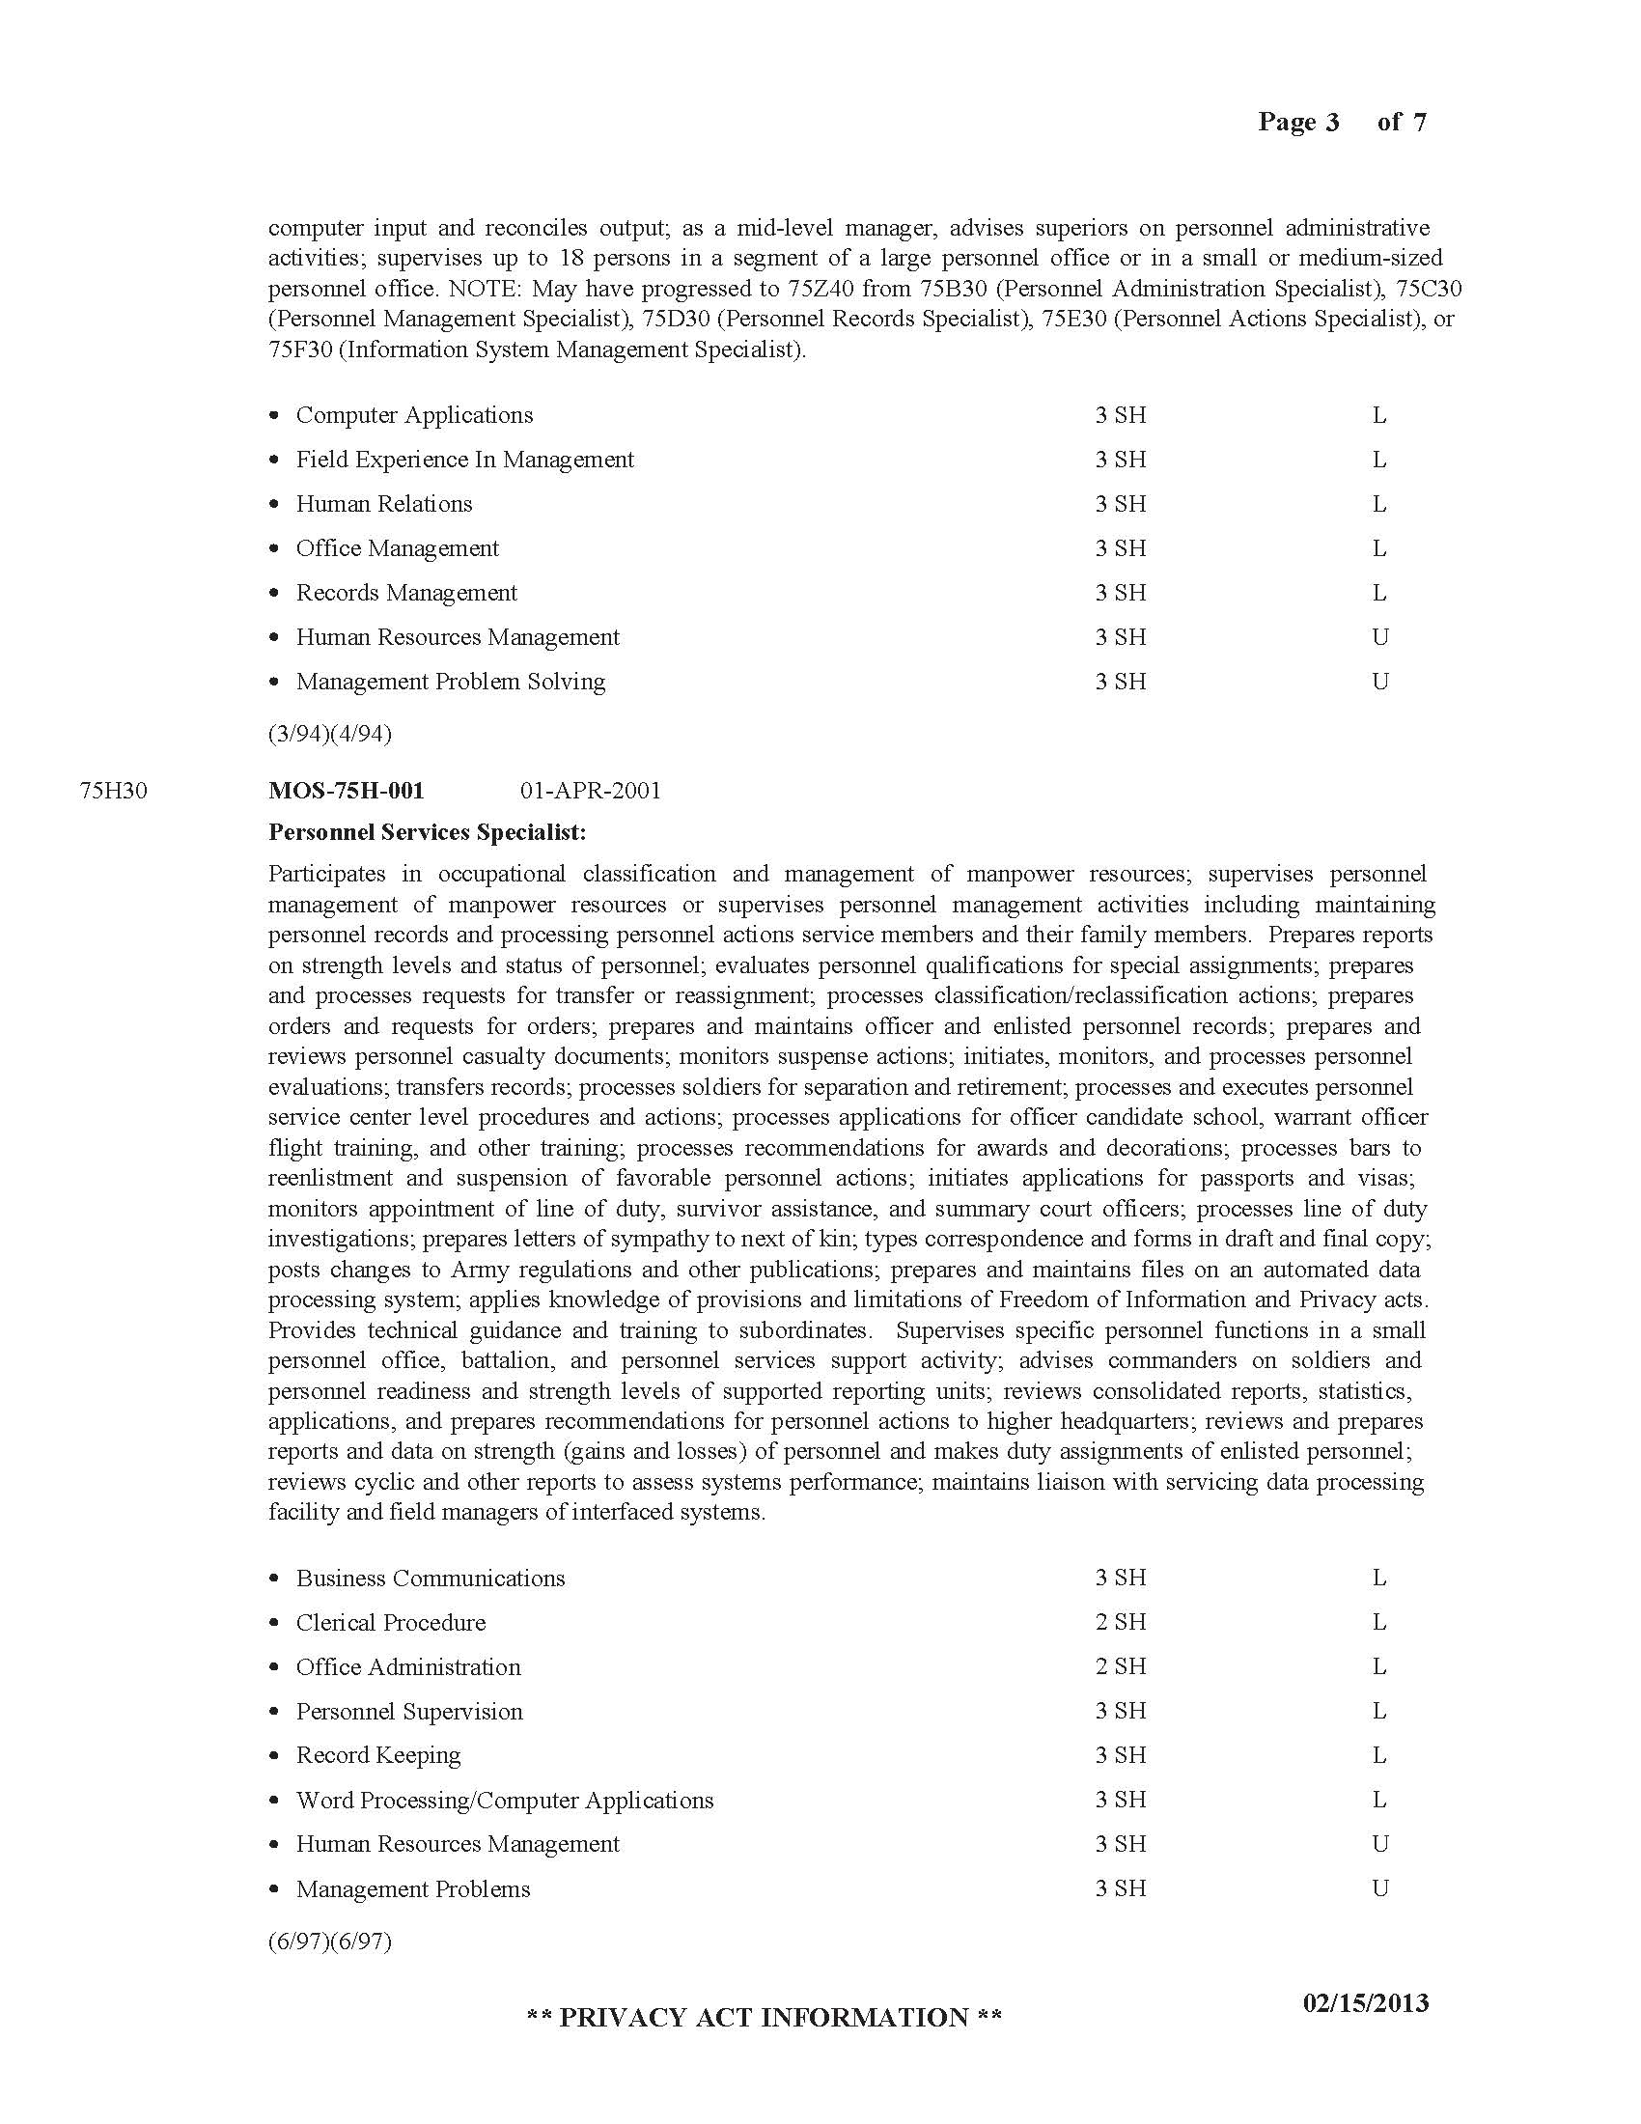

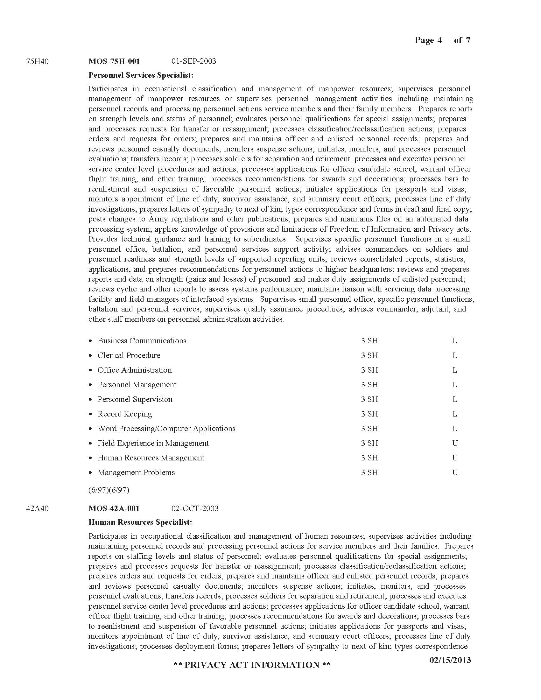

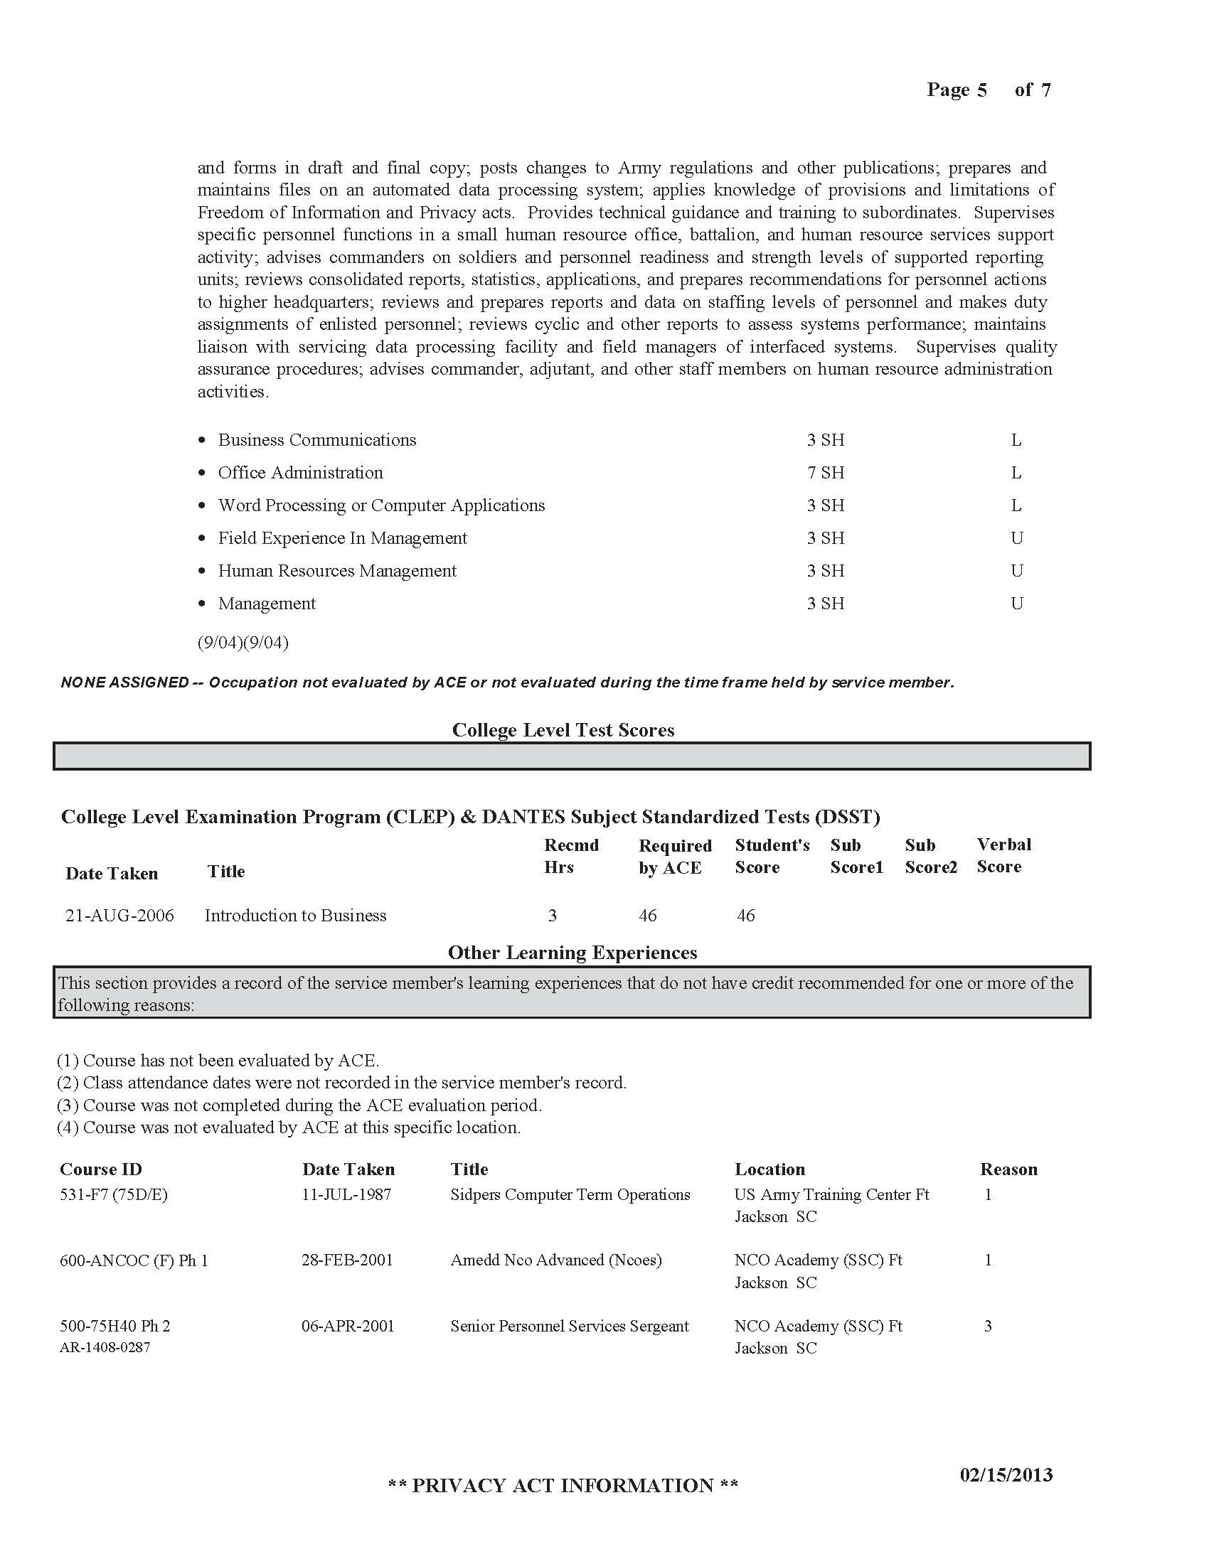



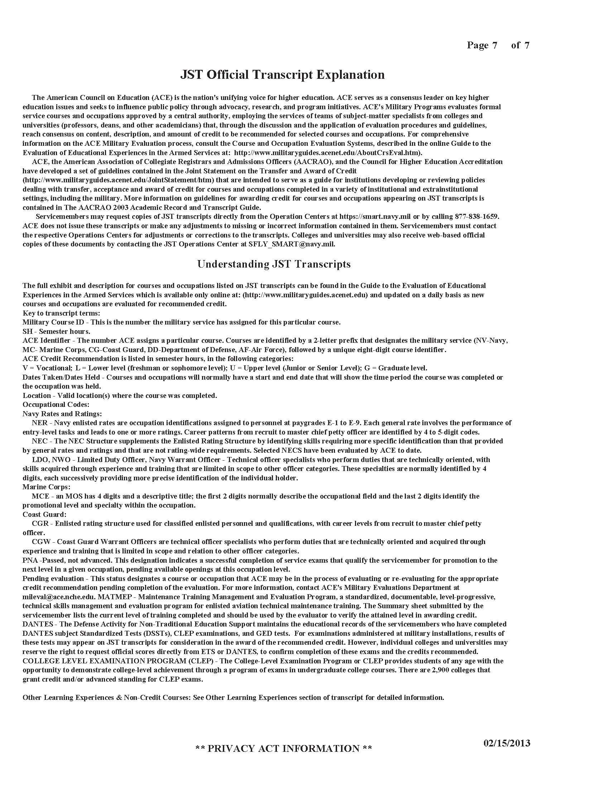

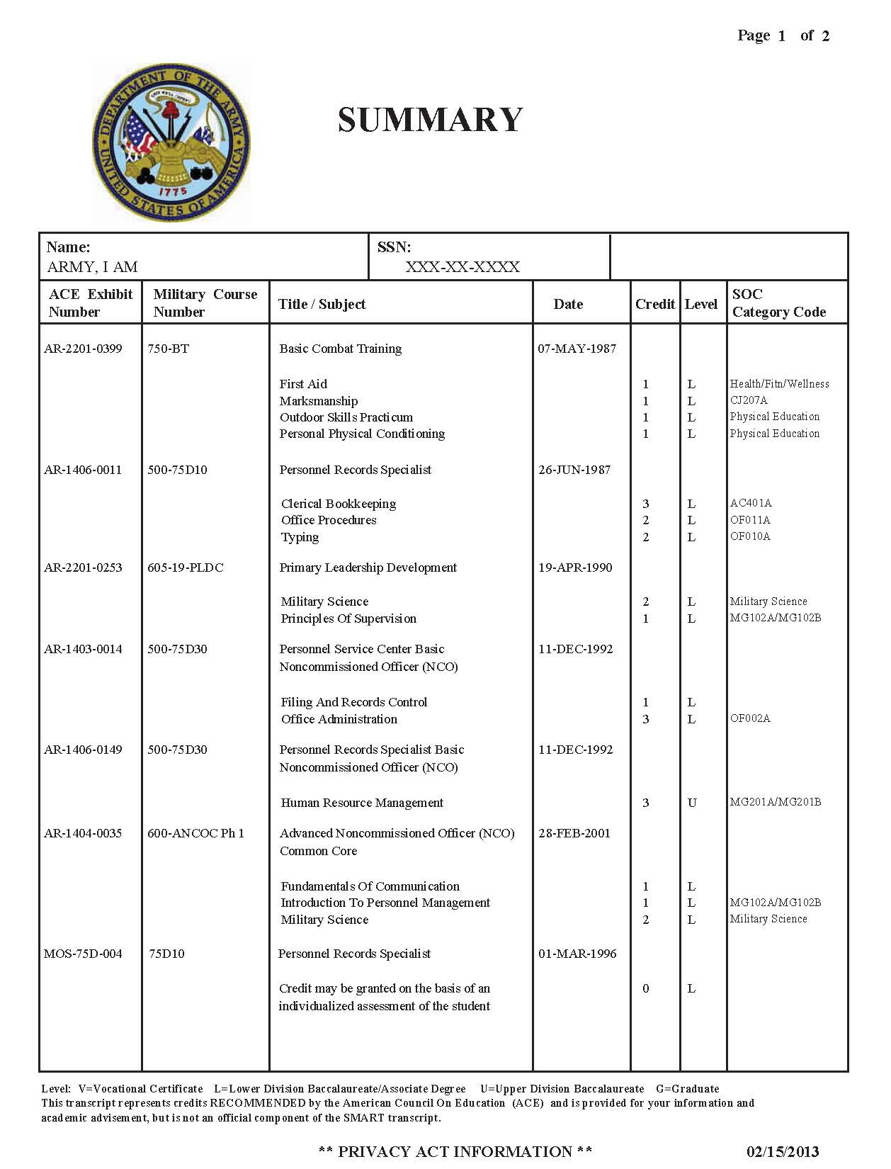

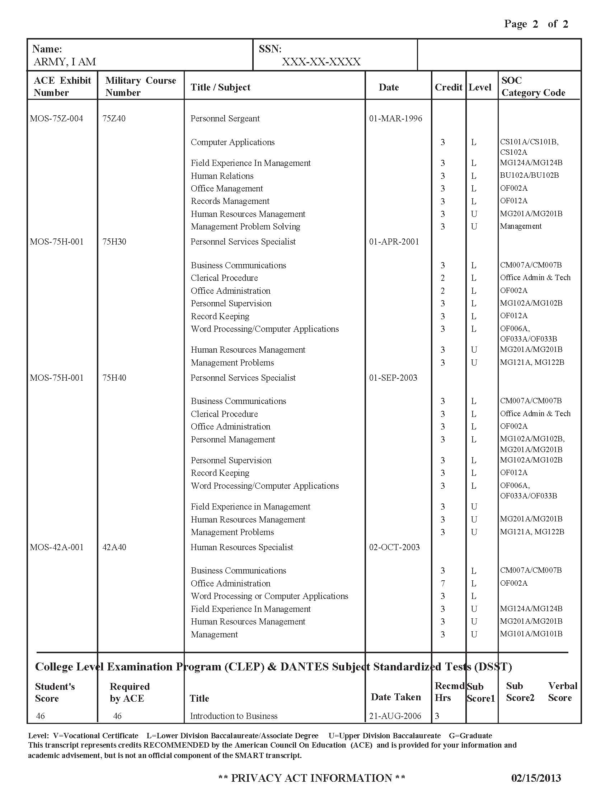

**Appendix D**

**Sample Webpage Design**

**Ivy Tech Community College, Indiana**

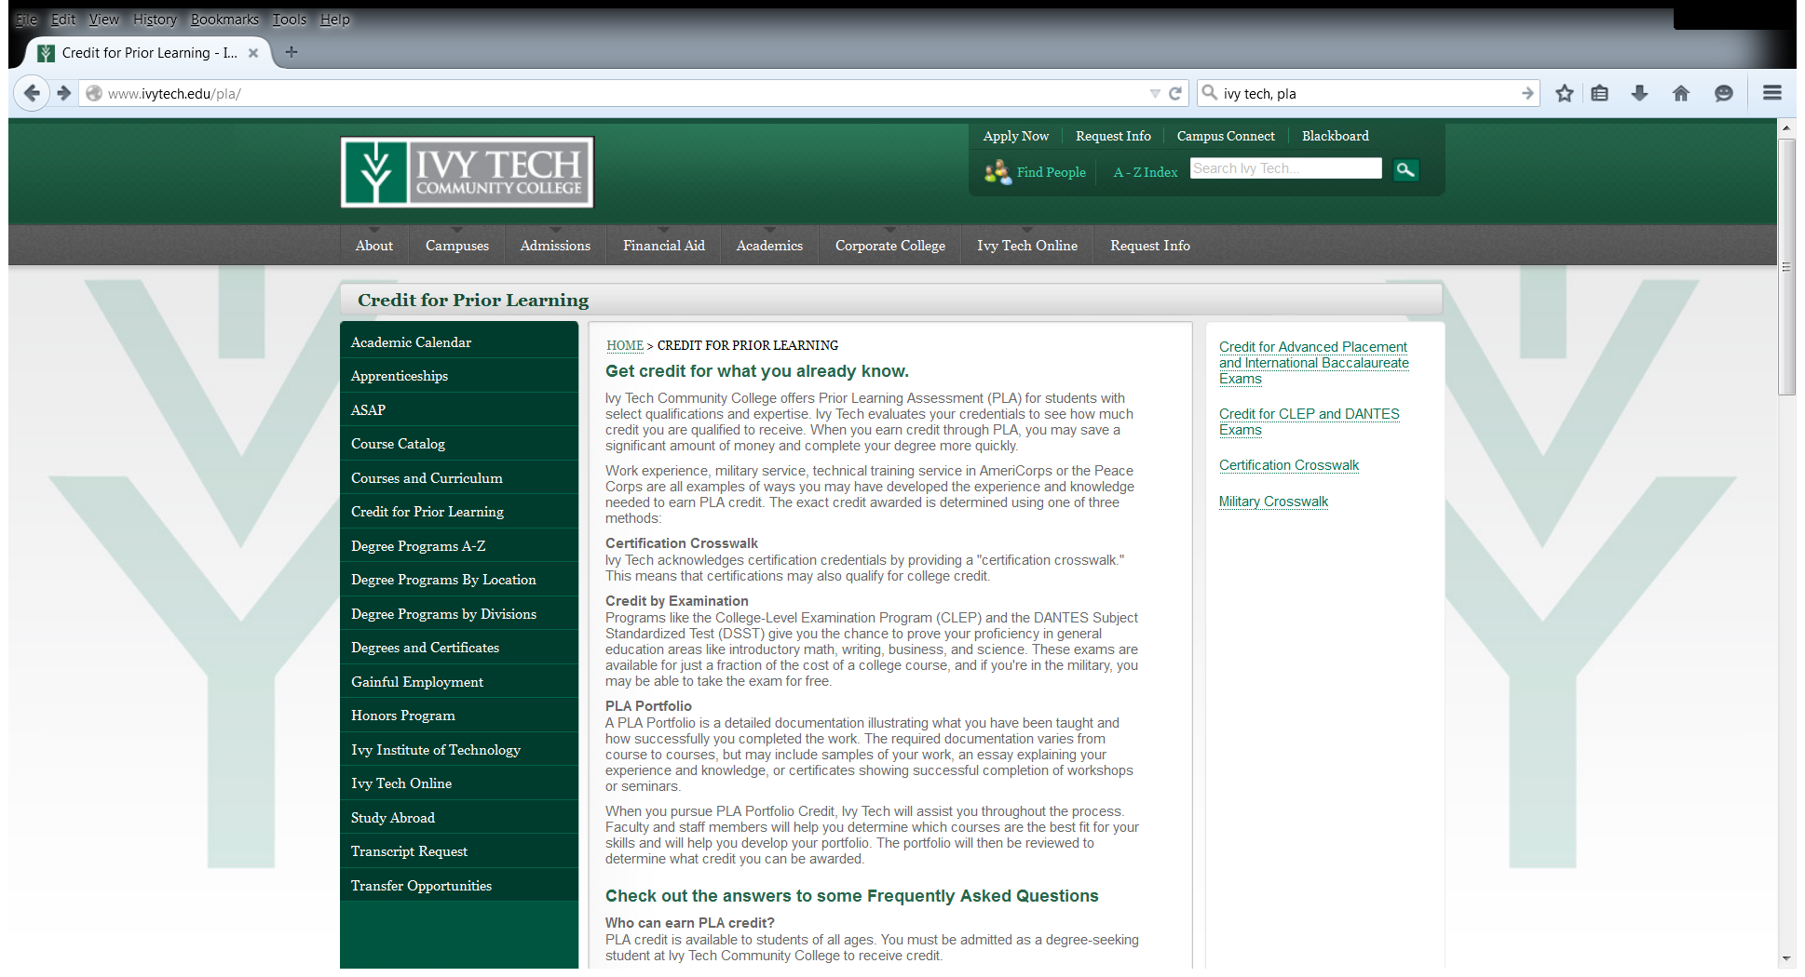

**http://www.ivytech.edu/pla/**

**Appendix E**

**Sample Crosswalks**

**Ivy Tech Community College, Indiana**

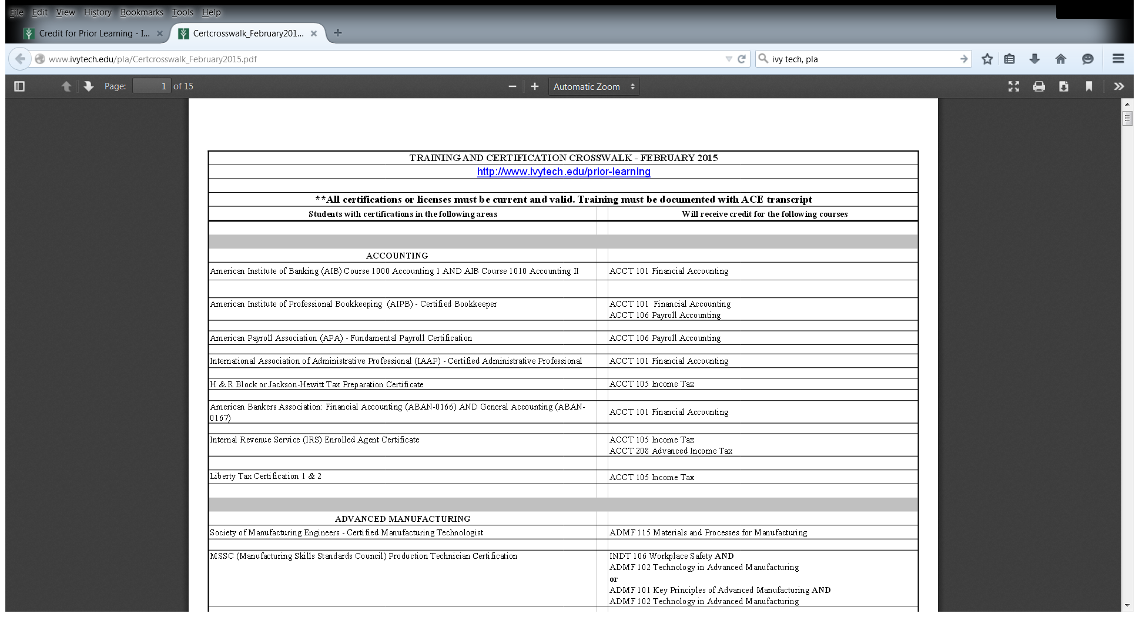

**http://www.ivytech.edu/pla/**

**Appendix F**

**Student Fees and Charges**

**Youngstown State University**

General Fee

* Program Fee: $30 per credit hour

Special Purpose Fees

* College Level Examination Program Test Fee (CLEP): $25
* Credit by Examination: $20 per credit
* Level 12 Fee: $300 per course (portfolio)
* Transfer Matriculation Fee: $35